
Strathroy Minor Lacrosse Association
667 Adair Blvd
Strathroy, ON
N7G 0A4

Date: ________________________
To Whom It May Concern;
For the purpose of Applicant: _____________________________________. Please be advised that a Vulnerable Sector Check / Police Criminal Record Check (Please circle the correct document) is required by the Strathroy Minor Lacrosse Association (SMLA) for the individual listed above. The applicant will be working in a volunteer capacity with children between the ages of___________________, in the role of __________________________________.

A brief description of the role is: ___________________________________________________________________________ ___________________________________________________________________________ ___________________________________________________________________________ ___________________________________________________________________________.

Volunteers within the SMLA assist youth on and off the arena/gym floor as well as in and out of the locker/change rooms. Should you require further information regarding the matter, please do not hesitate to contact me directly.
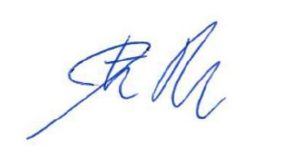
Sincerely,

Jon Balzer
President
Strathroy Minor Lacrosse
jb_7_7@yahoo.ca

